**INTERQUARTILE RANGE (IQR):**

**Why we are using 1.5?**

The factor of 1.5 has been found to work well in practice for many datasets, particularly those that are roughly normally distributed. It balances sensitivity to detect outliers while **minimizing false positives, and it most closely follows Gaussian distribution.**Changing this multiplier can lead to different definitions of what constitutes an outlier, which can be useful depending on the context of your analysis.

In summary, multiplying the IQR by 1.5 helps to create a reasonable boundary for identifying outliers in a dataset, based on the spread of the central portion of the data.As a result, the method dictates that any data point that's 1.5 points below the lower bound quartile or above the upper bound quartile is an outlier.

**ASSIGNMENT:**

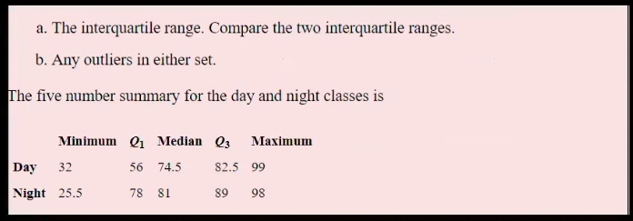

1. **. INTERQUARTILE RANGE**

|  |
| --- |
| IQR = Q3-Q1 |

IQR for Day Class = 82.5 - 56

= 26.5

IQR for Night Class = 89-78

= 11

**Lesser Outlier for Day Class**

Q1 - 1.5 (IQR) = 56-1.5(26.5)

= 56-39.75

= 16.25

**Greatest Outlier for Day Class**

Q3 + 1.5 (IQR) = 82.5+1.5(26.5)

= 82.5+39.75

= 122.25

**Lesser Outlier for Night Class**

Q1 - 1.5 (IQR) = 78-1.5(11)

=78-16.5

= 61.5

**Greatest Outlier for Night Class**

Q3 + 1.5 (IQR) = 89+1.5(11)

= 89+ 16.5

= 105.5

1. **. OUTLIERS**

There is one lesser outlier pesent in the night class(25.5 < 61.5)